IN 42
ELECTRONIC ICU BED, 4 MOTORS
Click for detailed video of the product
- Electrical operated backrest, height and legrest adjustment
- Electrical operated Trendelenburg, Reverse Trendelenburg, fowler and vascular position
- Patient handset
- Foot end nurse control unit
- Footrest adjustment by ratchet
- Auto-CPR
- Auto Regression system on backrest
- Auto contour
- Hygienic design (PP), lockable and tuck away side rails
- Easy removable ABS mattress platform
- Removable head and footboards
- Electrostatic epoxy painted metal frame
- Height adjustable IV pole
- Plastic protective crash bumpers on four corners
- Central Lockable Castors, 150 mm, Single
- Angle indicator for backrest
- Angle indicator for Trendelenburg and Reverse Trendelenburg positions
- Cardiac chair position with single button
- Shock position with single button
- Semi-Fowler position with single button
- Bed exit position with single button
- Examination position with single button
- Electronic CPR with single button
- Activation key at remote control to prevent any undesired positions
- Urine bag holder
- Urine basket (optional)
- Dual side manual CPR levers at backrest (optional)
- Rechargeable Battery Backup (optional)
- Bed size extension (optional)
- Twin Castors (optional)
- X-ray cassette holder at backrest (optional)
- IPX6 standard electronic system
 | TECHNICAL DETAILS
 | Overall Length: 216 cm | Castor Diameter: 15 cm
 | Overall Width: 102 cm | Under Bed Clearance: 15 cm
 | Height: 42-84 cm | Product Weight: 115 kg
 | Trendelenburg : 0°-16° | Safe Working Load: 250 kg
 | Reverse Trendelenburg: 0°-16° | Power In: 1.5A max. At 230V AC 50-60 Hz
 | Backrest Angle: 0°-70° | Electrical Shock Protection: Class I, Type B
 | Legrest Angle: 0°-35° | Liquid Ingress Protection: IPX6

ACCESSORIES
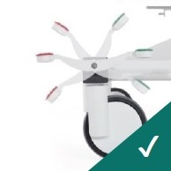
Central Brake Castors 150 mm
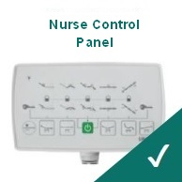
Foot-end Nurse Control Panel
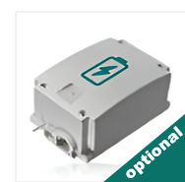
Rechargeable Battery Backup
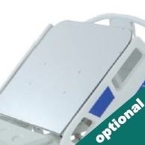
X-Ray Translucent Backrest with Cassette Holder
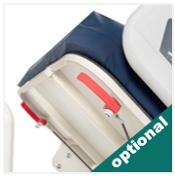
Dual Sided Manual CPR at Backrest
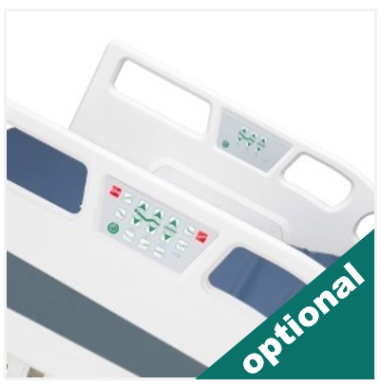
Control Panels Embedded on Side Rails
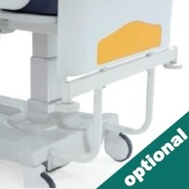
Stationary Headboard
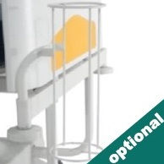
Oxygen Cylinder Holder
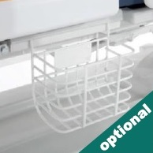
Urine Bag Basket
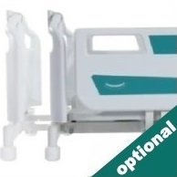
Bed Extension
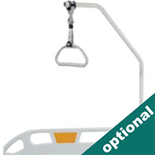
Lifting Pole
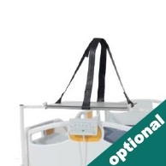
Monitor & Defibrillator Shelf
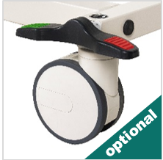
Double Wheels
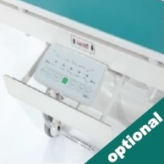
Nurse Panel Shelf
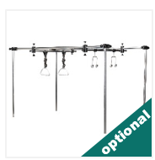
Orthopedic Traction System
COLOR CHART
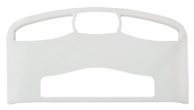
P01
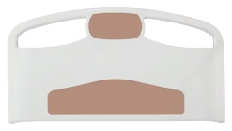
P02
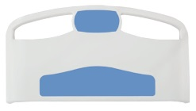
P03
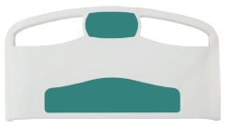
P04
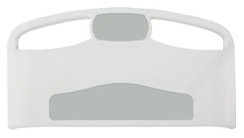
P05
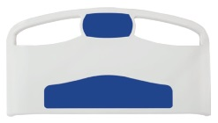
P06
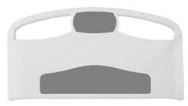
P07
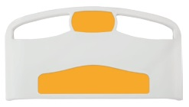
P08

